ADVANCED

Common Module

Texts and Human Experiences

NAME ____________________________________________________

Common Module: English Standard, English Advanced and English Studies
Texts and Human Experiences

In this common module students deepen their understanding of how texts represent individual and collective human experiences. They examine how texts represent human qualities (character traits) and emotions associated with, or arising from, these experiences. Students appreciate, explore, interpret, analyse and evaluate the ways language is used to shape these representations in a range of texts in a variety of forms, modes and media.

Why do individual human experiences matter?
_________________________________________________________________________________________________________________________________________________________________________________________________________________________________

How do collective human experiences shape our worlds?

_________________________________________________________________________________________________________________________________________________________________________________________________________________________________

What are the ecological systems that shape individuals and societies?
_________________________________________________________________________________________________________________________________________________________________________________________________________________________________

Give 5 examples of positive human qualities and 5 negative examples.

Positive | Negative

Name 10 basic human values.

_________________________________________________________________________________________________________________________________________________________________________________________________________________________________

What are the eight primary emotions according to Plutchik?

_________________________________________________________________________________________________________________________________________________________________________________________________________________________________

Students explore how texts may give insight into the anomalies, paradoxes and inconsistencies in human behaviour and motivations, inviting the responder to see the world differently, to challenge assumptions, ignite new ideas or reflect personally. They may also consider the role of storytelling throughout time to express and reflect particular (context) lives and cultures. By responding to a range of texts they further develop skills and confidence using various literary devices, language concepts, modes and media to formulate a considered response to texts.

Define anomalies, paradoxes and inconsistencies with examples from the text

Anomalies | Paradoxes | Inconsistencies

What particular lives and cultures are expressed in your prescribed text?
_________________________________________________________________________________________________________________________________________________________________________________________________________________________________
_________________________________________________________________________________________________________________________________________________________________________________________________________________________________

Students study one prescribed text and a range of short texts that provide rich opportunities to further explore representations of human experiences illuminated in texts. They make increasingly informed judgements about how aspects of these texts, for example context, purpose, structure, stylistic and grammatical features, and form shape meaning. In addition, students select one related text and draw from personal experience to make connections between themselves, the world of the text and their wider world.

How are you going to decide upon your related text? What will be your primary focus?

_________________________________________________________________________________________________________________________________________________________________________________________________________________________________
_________________________________________________________________________________________________________________________________________________________________________________________________________________________________

By responding and composing throughout the module students further develop a repertoire of skills in comprehending, interpreting and analysing complex texts. They examine how different modes and media use visual, verbal and/or digital language elements. They communicate ideas using figurative language to express universal themes and evaluative language to make informed judgements about texts. Students further develop skills in using metalanguage, correct grammar and syntax to analyse language and express a personal perspective about a text.

What language features are you expected to recognise, develop, and utilize in in your responses?

Language Feature | Definition | Example

What is a universal theme? Give three examples

_________________________________________________________________________________________________________________________________________________________________________________________________________________________________
_________________________________________________________________________________________________________________________________________________________________________________________________________________________________

HUMAN BEHAVIOUR
People play an active role in creating their experiences
Every human is different yet the same, explain this statement.
_________________________________________________________________________________________________________________________________________________________________________________________________________________________________
_________________________________________________________________________________________________________________________________________________________________________________________________________________________________

HUMAN VALUES:
Human values are the principles, standards, convictions, and beliefs that people adopt as their guidelines in daily activities. Principal human values are the foundations on which ethics are built. They are a set of consistent measures and behaviours that individual choose to practice in the pursuit of doing what is right or what is expected of them by society. Most laws and legislation are shaped by human values.

TYPES OF VALUE

Define

Moral value _______________________________________________________________
Ethical value ______________________________________________________________
Social value _______________________________________________________________
Professional value __________________________________________________________
Aesthetic value _____________________________________________________________
Psychological value _________________________________________________________

SCHWARTZ’S THEORY OF BASIC VALUES

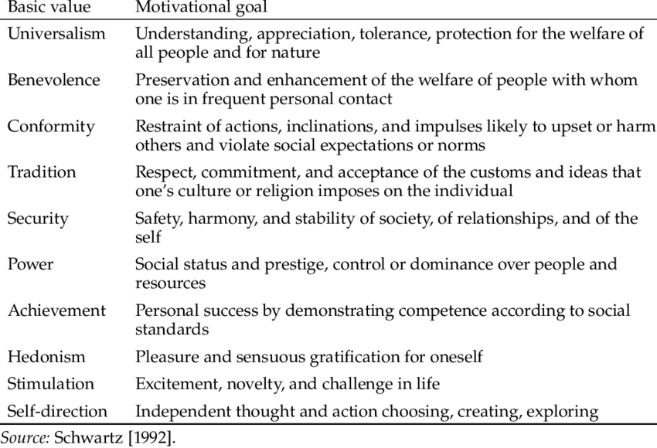

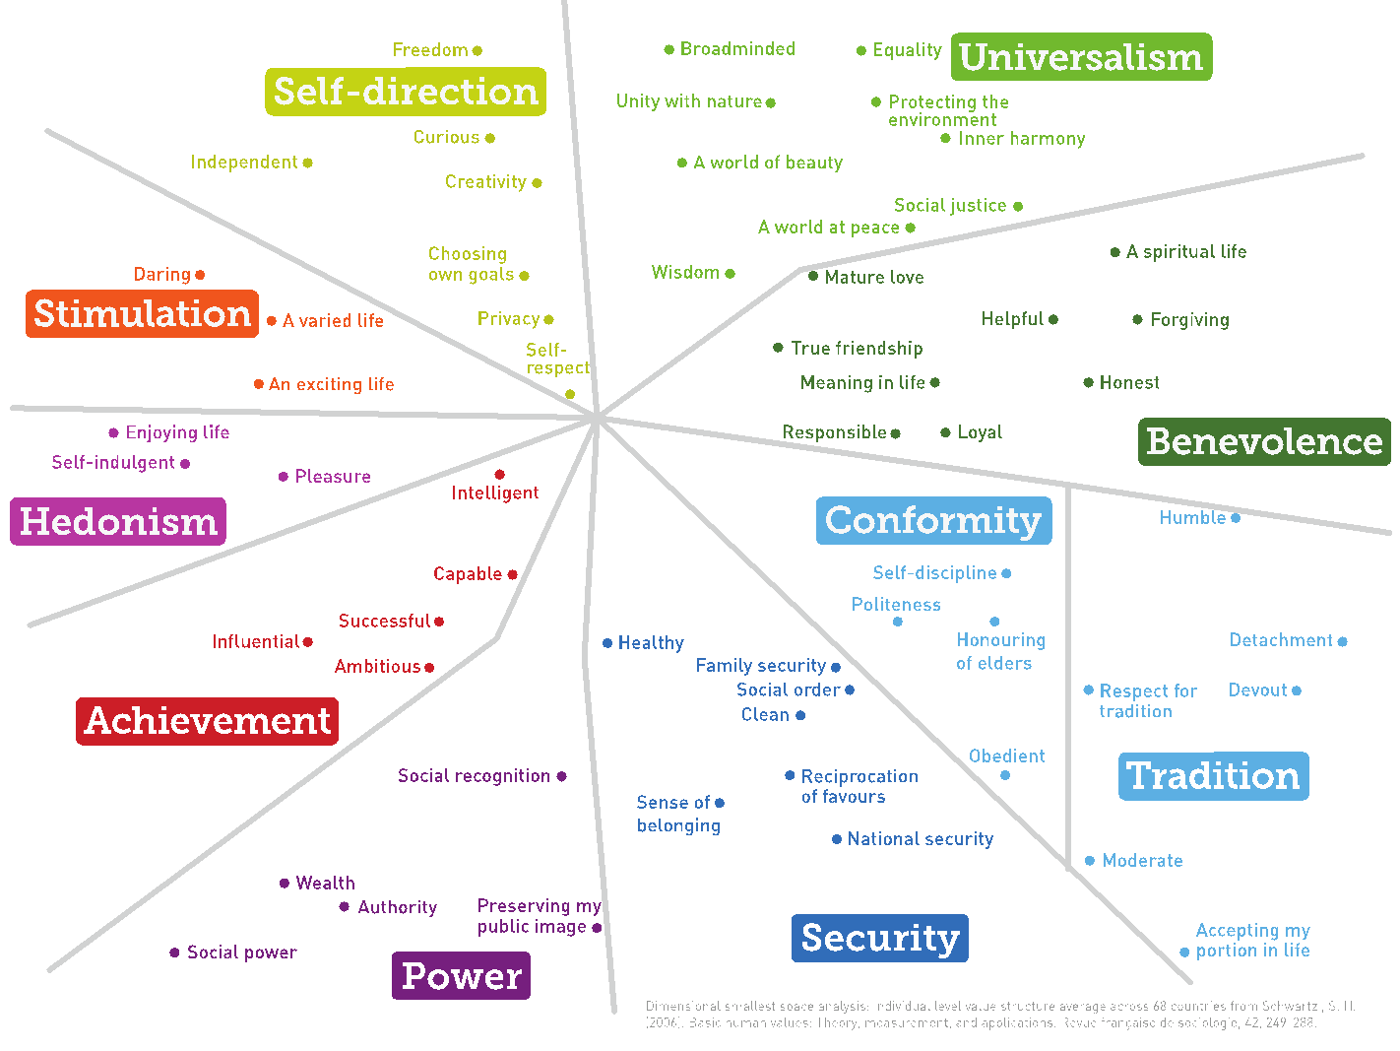

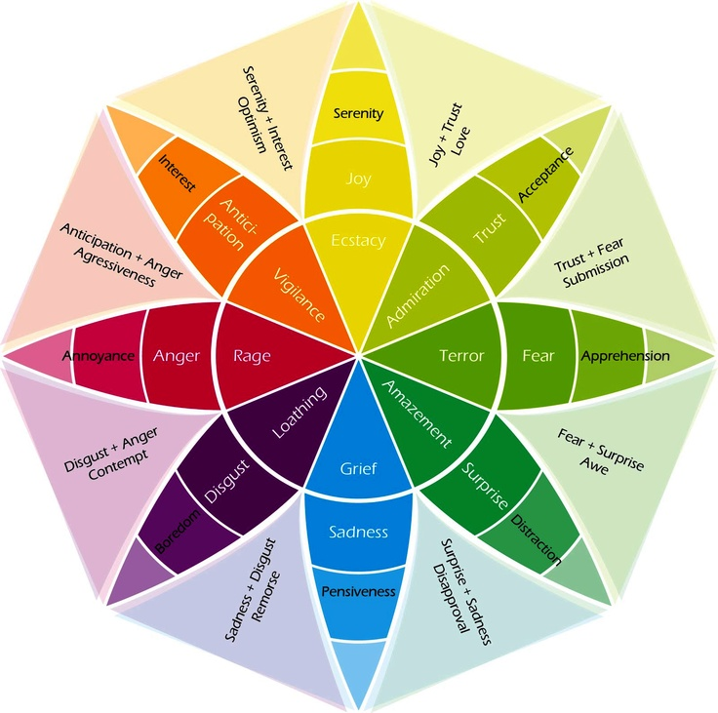

Plutchik’s Wheel of Emotions

Bronfenbrenner’s ecological systems

Bronfenbrenner’s (1979) bioecological model, which highlights the transactional nature of multiple levels of influence on human development, conceptualizes humans as nested within four levels (see Figure 3-2). The most proximal system is the microsystem (e.g., school, family), which includes immediate surroundings that more directly affect the individual. The next level of influence, the mesosystem, describes how the different parts of a child’s microsystem interact together. The exosystem includes neighborhoods or school systems. The macrosystem includes the broad norms and trends in the culture and policies, which impact development and behavior.

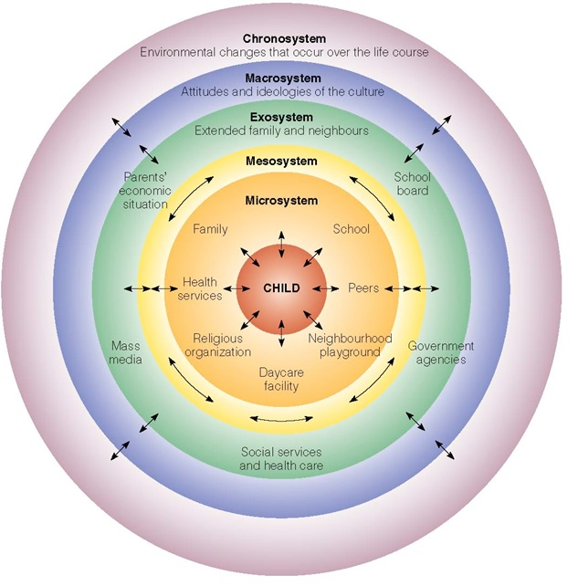

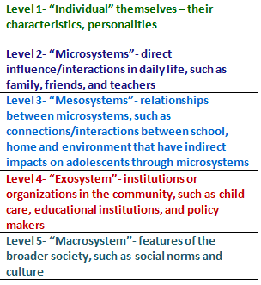

What is level 6? How do we see it in The Crucible?

__________________________________________________________________________________________________________________________________________________________________________________________________________________________________________________________________________________________________________________________________________________________________________________________________________________________________________________________________

__________________________________________________________________________________________________________________________________________________________________________________________________________________________________________________________________________________________________________________________________________________________________________________________________________________________________________________________________

__________________________________________________________________________________________________________________________________________________________________________________________________________________________________________________________________________________________________________________________________________________________________________________________________________________________________________________________________

Select a character from The Crucible and apply Bronfenbrenner’s ecological systems theory to map out the world of your character.






