Let’s start with The Tempest

Context

The King’s Men and Early Performance History

The first documented staging of The Tempest was in 1611, 1 November at London’s Whitehall Palace,

James I was an avid patron of theatre and playwrights. Under royal patent, Shakespeare's troupe, The Chamberlain’s Men became the King's Men and with the king’s patronage, the company had many opportunities to perform for royalty.

In 1608, with the opening of the Blackfriars Theatre, they had a permanent indoor winter theatre which provided them with new theatrical opportunities and a wealthy and highly educated audience. The theatre also had a tradition of breaks between each act which Shakespeare utilised to dramatic benefit.

The King’s Men also performed at court by special request. One of the first. performances of The Tempest (1611-12) was in the Banqueting House at Whitehall on 1st November 1611 which had wonderful machinery for scenes that involved clouds and performers’ flying entrances.

The Tempest was written to suit James’ concerns, its subject matter dealing with conspiracy (James had a few years before survived the Gunpowder Plot), its themes of authority, control and ‘natural order’ and its supernatural elements, which held a long-time fascination for the king. The performance was repeated a year later at the wedding of James I’s daughter Elizabeth to Frederick, Prince Palatine, an appropriate choice with the marriage of Miranda and Ferdinand (in The Tempest) mirroring the royal union and the masque paying homage to connubial harmony. James, (and The Tempest character Prospero), knew the importance of strategic alliances. In this play Shakespeare shows himself a master of political finesse through the character of Prospero, where James would see some reflection of his own role as a wise ruler.

The Tempest – historical context

Age of Discovery

Shakespeare lived in an ever-expanding world where ‘new’ lands were being discovered as men sought gold and glory while spreading the word of god with missionaries. Elizabeth 1 had supported the age of exploration. England, like many other countries of Europe, began to seek new lands and riches, desiring prestige and wealth and asserting dominance over the new colonies. Many stories abounded about the cannibals (anthropophagi) and even monsters in these places. The natives they encountered were scorned or treated as freaks to be displayed (‘Shakespeare’s Tempest and the American Indian’ http://www.columbia.edu/~lnp3/mydocs/culture/tempest.htm)

Landmark discoveries included:

- 1581: Francis Drake reached the Cape of Good Hope showing that there were distant places to be discovered with different people .

- 1607: The British colonisation of the Americas began in Jamestown, Virginia.

- 1609, 28 July: The Sea Venture, flagship of a fleet on route to the Virginia Colony, is dashed by a hurricane onto Bermuda reefs but all hands survive, including Sir Thomas Gates, Sir George Somers and William Strachey.

Cultural

Jacobean England was experiencing an epochal period of change with a transformative shift from the absolute power of the Church and the belief in Providentialism to the Renaissance belief in self-determinism and the pursuit if self-knowledge. Shakespeare cleverly weaves both paradigms to create Christian humanism. Humanists believed that self-knowledge was the ultimate purpose in life. The ancient adage nosce te ipsum – know thyself – was a key principle of humanist

thought. Humanity could still pursue dreams and aspirations, provided this was guided by moderation, compassion and virtue. This is evident through Prospero who epitomises by the end of the play

© English Teachers Association NSW

The Tempest and Hag-Seed – Module A: Textual Conversations

Renaissance Christian Humanist thought: ‘Yet with my nobler reason ‘gainst my fury do I take part:
the rarer action is in virtue than in vengeance.’

Social

King James I introduced to England, the European political and religious doctrine of the Divine Right of Kings. This doctrine of royal and political legitimacy claimed that a monarch was subject to no earthly authority, such as parliament, and answered only to God who has given the monarch the right to rule. From the very outset of his reign James showed his inability to grasp the ideas of government which had become ingrained in the English people – ideas which were thoroughly understood by the Tudors and which none of them would ever have been tactless enough to ignore. This doctrine signaled the beginning of a clash between James I and parliament. Committing regicide – murder of a King or Queen – was a crime against God.

Attitudes to magic

1583–8: John Dee who probably influenced Shakespeare’s representation of Prospero was the prominent mathematician, astrologer, alchemist, philosopher and reputed magician as Queen Elizabeth’s advisor, the ruling monarch before James.

Cultural and social

The Tempest acknowledges the Renaissance Great-Chain-of-Being with its representation of the hierarchy from the angelic to the bestial – from Ariel and Caliban – with a full spectrum of dissolute and virtuous characters in-between.

Self-determinism heightened by the emergence of the merchant class exposed humanity’s

flaws. Humanist philosopher, Erasmus wrote in Enchiridion militis Christiani in 1503 'know yourself; do not allow yourself to be led by the passions, but submit all things to the judgement of reason’.

Personal and cultural:

Shakespeare as a Christian humanist, extols the Christian values of compassion, moderation and forgiveness and the humanist virtue of ‘philanthropia’ – love of humanity. One of the distinctive features of modernity essential to the humanism that Shakespeare scrutinises in The Tempest is that man decides his fate. This is a humanist play through Prospero's abjuration of magic, his return to Milan, and the restoration of a civil order--that the ultimate end of these acts in which man governs his life depends upon a human being embracing compassion and his humanity guided by Christian tenets.

Literary Influences

The Renaissance period in which this is written was also a time of literary discovery. Many Ronan and Greek texts were rediscovered and we see the influence of these texts. Virgil’s The Aeneid (29-19BC) influenced The Tempest with its complex treatment of the discourses of epic imperialism, colonialism, and the problems of sovereignty, but also its use of empathy in a way that blends poetry and the moral imagination.

Other literary influences on The Tempest were:

- 1603: John Florio’s translation into English of Michel de Montaigne’s Essayes, originally published in French in 1580.

- ‘Of the Caniballes’ and Thomas More’s Utopia (1516) are the sources for Gonzalo’s utopian speech - https://dcc.newberry.org/collections/shakespeare-tempest-utopias-european-renaissance For more lessons on Utopia go to the British Library site: http://www.bl.uk/learning/histcitizen/21cc/utopia/more1/moreutopia.html
- All of these have intertextual resonances for those who have read them

© English Teachers Association NSW
The Tempest and Hag-Seed – Module A: Textual Conversations

Context Activity

From the history to the play and then the appropriation

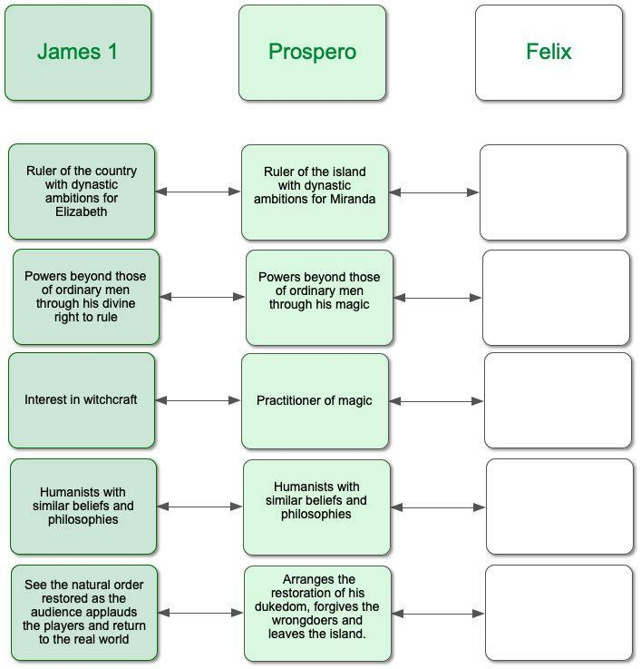
The following table shows how the Jacobean world was translated into the play The Tempest. When you start reading Hag-Seed come back to this table and compete the final column using your knowledge from Hag-See

